**1. Introduction**

The proposed project aims to develop a landing page for a Newari Kitchen. The landing page will serve as the online presence for the restaurant, providing customers with essential information about Newari cuisine, location, menu offerings, and contact details. This project is designed to enhance the restaurant's visibility and attract potential customers through an engaging and informative online platform.

The web page will feature a visually appealing design that reflects the cultural richness and authenticity of Newari cuisine. It will be optimized for both desktop and mobile devices to ensure a seamless browsing experience for users across various platforms. Additionally, the page will incorporate interactive elements such as menus, photo galleries showcasing Newari delicacies, and contact forms to encourage user engagement and facilitate easy access to information.

Overall, the development of this Newari Kitchen landing page aligns with the restaurant's goal of expanding its online presence and reaching a wider audience of food enthusiasts interested in experiencing authentic Newari flavors and culture.

**2. Objectives**

* Showcase the restaurant's unique menu offerings and culinary specialties.
* Highlight the restaurant's ambiance and dining experience through high-quality images and descriptions.
* Provide easy access to reservation and contact information.
* Integrate social media links to enhance customer engagement and outreach.
* Establish a visually appealing and user-friendly online presence for the restaurant.

**3. Scope**

* Create a detailed menu section with descriptions and images.
* Incorporate a gallery showcasing the restaurant's interior and exterior.
* Implement an online reservation system.
* Integrate social media platforms for increased visibility and interaction.
* Design and develop a responsive website with intuitive navigation.

**4. Problem Statement**

The proposed restaurant, "NewaSpice," aims to offer an authentic dining experience featuring traditional Newari cuisine, rich in cultural heritage and flavor. In a time when the appreciation for traditional Newari culture is diminishing, NewaSpice seeks to revive and celebrate this culinary heritage. Despite its exceptional offerings and immersive ambiance, NewaSpice currently lacks an online presence to attract and engage potential customers. This project addresses the need to establish a comprehensive digital platform to showcase the restaurant's unique menu, cultural ambiance, and exceptional services. By creating an engaging and Functional website, the project aims to enhance visibility, drive customer engagement, and make it easier for potential diners to discover and experience the culinary delights of Newari Cuisine, thereby contributing to the preservation and revival of traditional Newari cuisine.

**5. Methodologies**

To create a successful online presence for NewaSpice, we will employ a structured and systematic approach. This includes requirement analysis to understand the project's needs, followed by the design and development of a user-friendly and visually appealing website. Content creation will focus on highlighting NewaSpice’s unique cultural and culinary offerings.

Comprehensive testing will ensure functionality and user experience, culminating in the deployment and ongoing maintenance of the website. This methodology ensures that the project goals are met efficiently and effectively.

Following are the methodologies that will be used in the development of the landing page:

**Agile Development:** Agile development is an iterative and collaborative approach to software development that emphasizes flexibility and rapid delivery of working software.

**5.1 Phases of Agile Methodologies**

Following are the phases in the agile model are as follows:

a. Requirements gathering

b. Design the requirements

c. Construction/ iteration

d. Testing/ Quality assurance

e. Deployment

f. Feedback

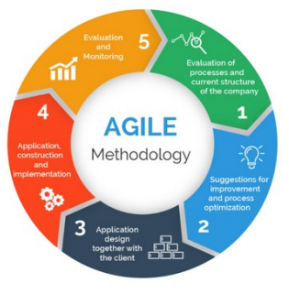

a.Requirements gathering: Gather detailed requirements and preferences from stakeholders regarding the design, content, and functionality of the landing page.

b. Design the requirements: Create wire-frames and mock ups based on the requirements, followed by the development of the landing page using modern web development technologies.

c. Construction/ iteration: When the team defines the requirements, the work begins. Designers and developers start working on their project, which aims to deploy a working product. The product will undergo various stages of improvement, so it includes simple, minimal functionality.

d. Testing: Conduct thorough testing to ensure functionality, usability, and compatibility across different devices and browsers.

e. Deployment: In this phase, the team issues a product for the user's work environment.

f. Feedback: After releasing the product, the last step is feedback. In this, the team will gather feedback from stakeholders and make necessary revisions.

**6. Data Flow Diagram**

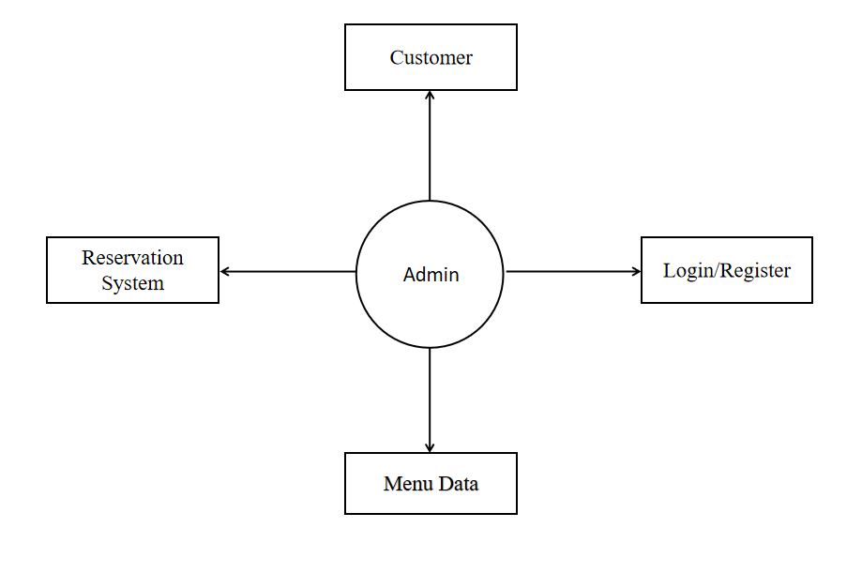

**7. Use Case**

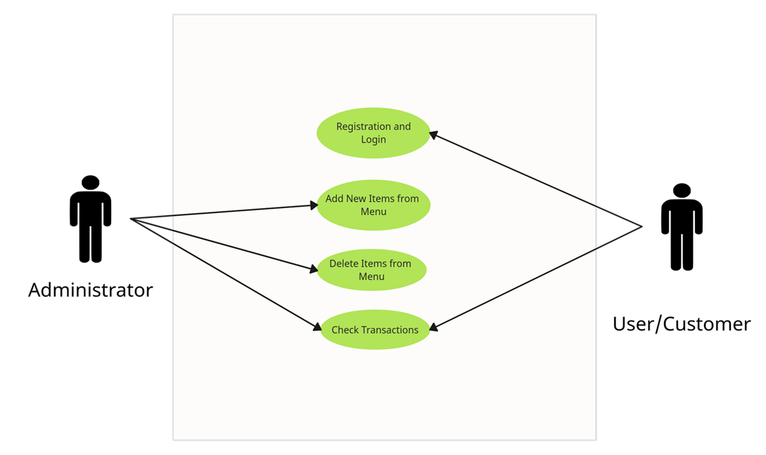

**8. Technology**

* Web Technology: HTML, CSS & JavaScript are used to develop user interface and functionality of the restaurant landing page. Figma for wire-frame designing.
* Bootstrap: A front-end development framework used to enable responsive development of mobile-first websites; Bootstrap provides a collection of syntax for template designs.
* JQuery: A JavaScript library which we will use to validate our user registration and login forms.
* React.js: A JavaScript library and framework which we will use to create dynamic UI for our user registration form.
* Git and Git-hub: A version-source control system to track code and share code.
* JSON and JSON Server: a server for mock-api.

**9. Timeline/ Milestone**

For a period of three months, the project is carried out as per following timelines:

**For Month 1:**

* Gather the requirements and identify the features and functionalities needed in the restaurant landing page.
* Creating mock-ups and wire-frames for the layout of the system before starting actual coding work.

**For Month 2:**

* Actual development of the website, including coding, bug fixing and testing.
* Integrate all functional and non-functional features required for smooth UI and functionality while keeping in mind the customer experience.

**For Month 3:**

* Testing the website to ensure that it is functioning as expected and deploying it to a live environment.
* Finalize testing and provide required maintenance and support.

**10. Expected Outcomes**

Upon completion of this project, NewaSpice will have a robust online platform that effectively showcases its traditional Newari cuisine and cultural heritage. The website will provide easy access to the restaurant's menu, ambiance, and reservation system, enhancing customer engagement and accessibility. By reviving and celebrating traditional cuisine in the digital realm, NewaSpice aims to attract a broader audience while contributing to the preservation of Newari culture. This comprehensive online presence will establish NewaSpice as a prominent culinary destination, both locally and beyond.

**11. Functional Requirements**

* Homepage: Introduction to the restaurant, featured dishes, and call to-action buttons.
* Menu Page: Showcase of menu items with descriptions, prices, and images.
* Log In or Signup Page: Login and signup functionality
* Contact Page: Contact form, address, phone number, and map.
* Reservation Page: Reservation form with date, time, party size, and special requests.

**12. Deliverables**

* Fully functional restaurant landing page with all specified sections and features.
* Visually appealing graphics and images that represent the restaurant's ambiance and cuisine.
* User-friendly reservation system integrated with the restaurant's booking platform.
* Documentation outlining the design, development, and maintenance of the landing page.

**13. Risks and Challenges**

* Limited resources and time constraints may affect the project timeline and deliverables.
* Changes in requirements or preferences from stakeholders could lead to scope creep and delays.
* Technical issues or compatibility issues with web browsers and devices may arise during development.
* Ensuring search engine optimization (SEO) and online visibility may require ongoing efforts beyond the initial launch of the landing page.

**14. References**

javatpoint.com: https://www.javatpoint.com/agile